How to burn the firmware to flash
- Get the file all we need;
- Install the install_digilent.exe;
- Reboot the computer;
- Cope the burn_flash folder to the sd card;

- Insert the SD card into the module and connect to the computer through the debug port
- Find the uart port;
- 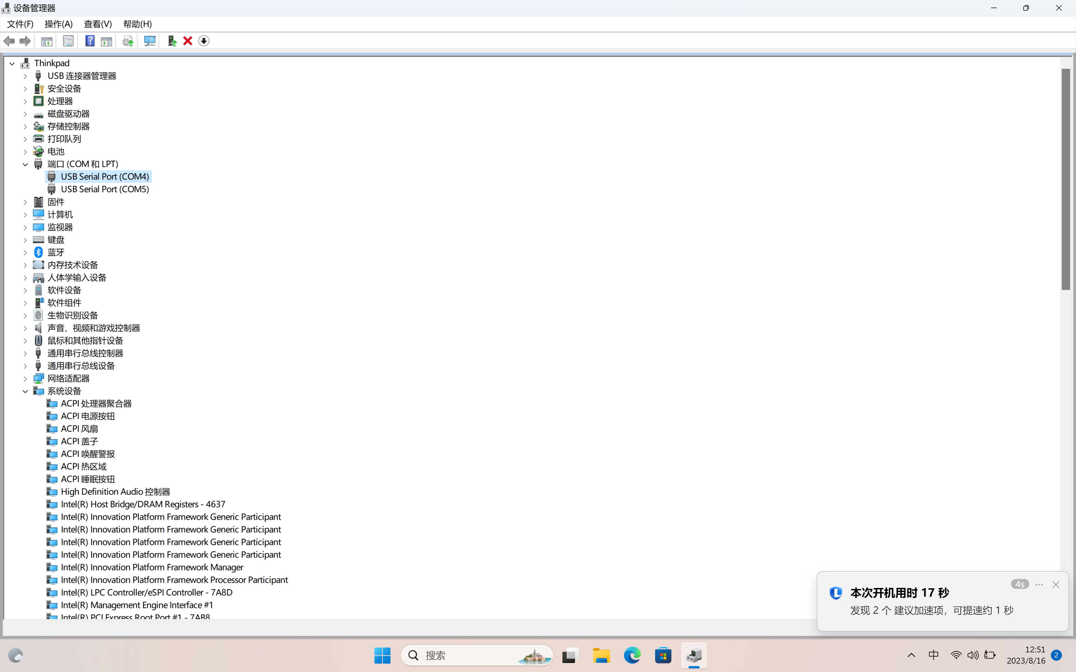
- Use the 2ed port as an console;
- Open the putty
- 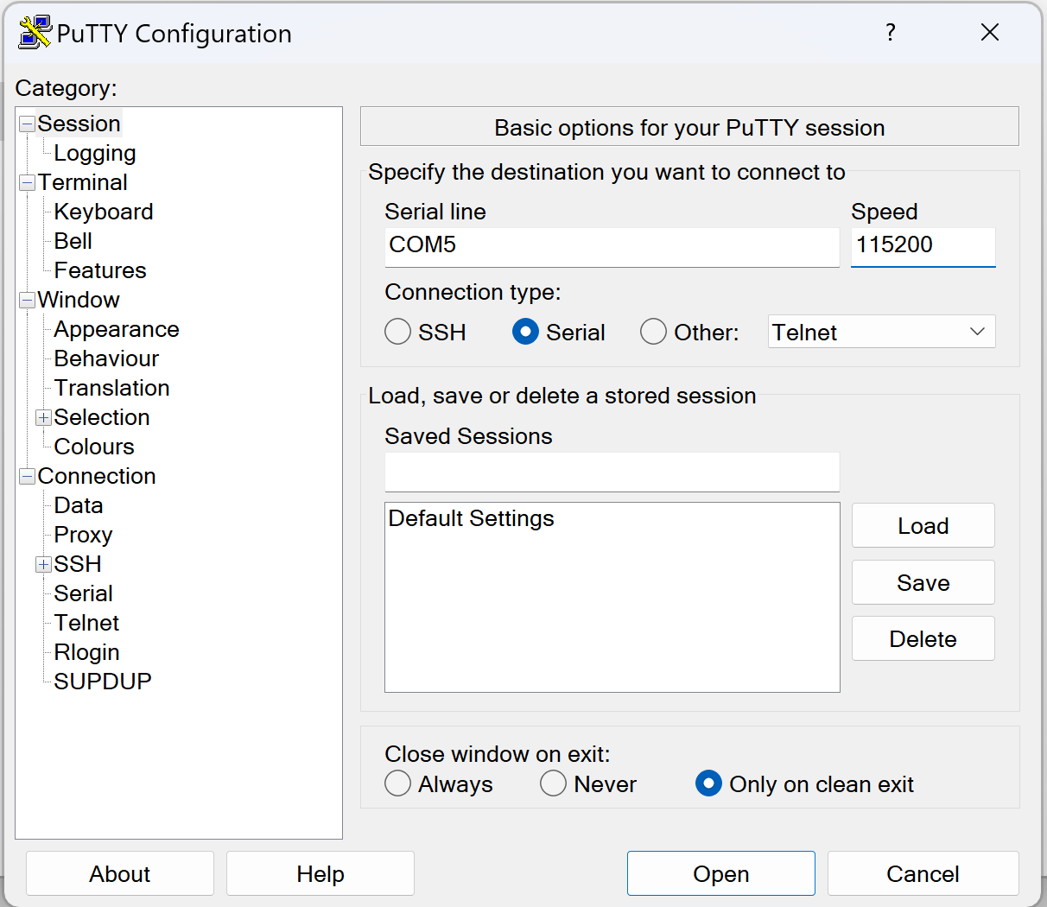
- Click the open
- Type the end we will get an linux console;
- 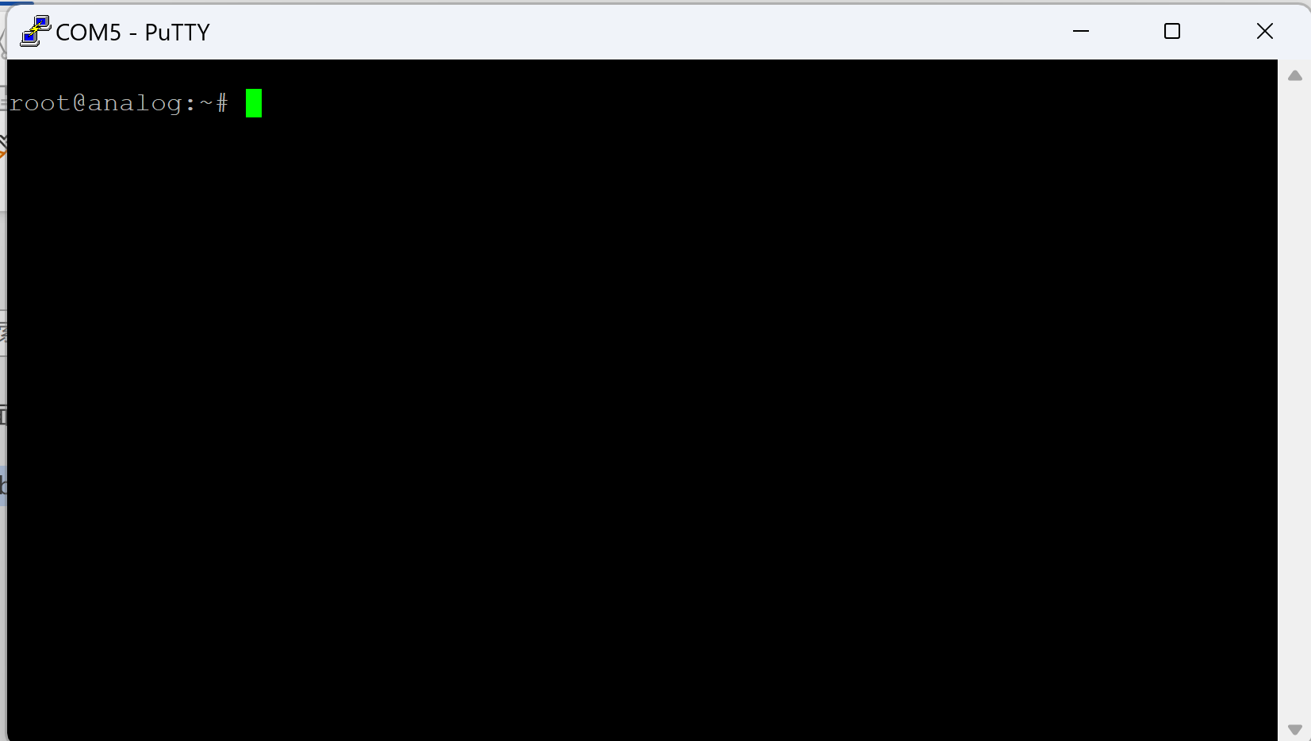
- 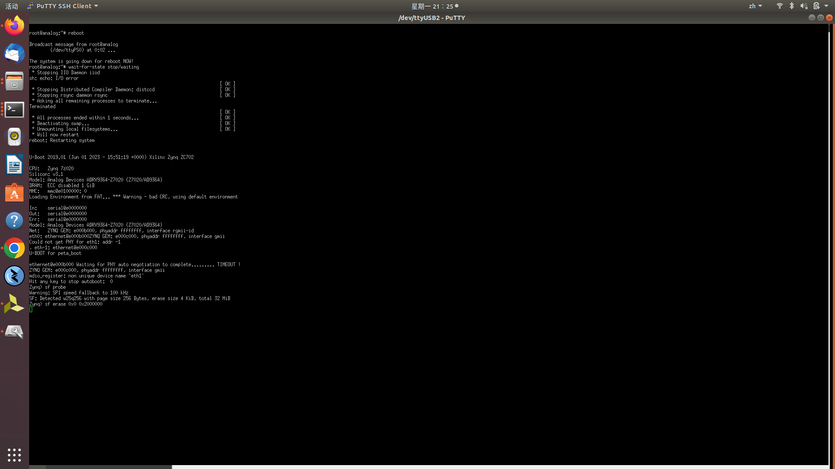
- 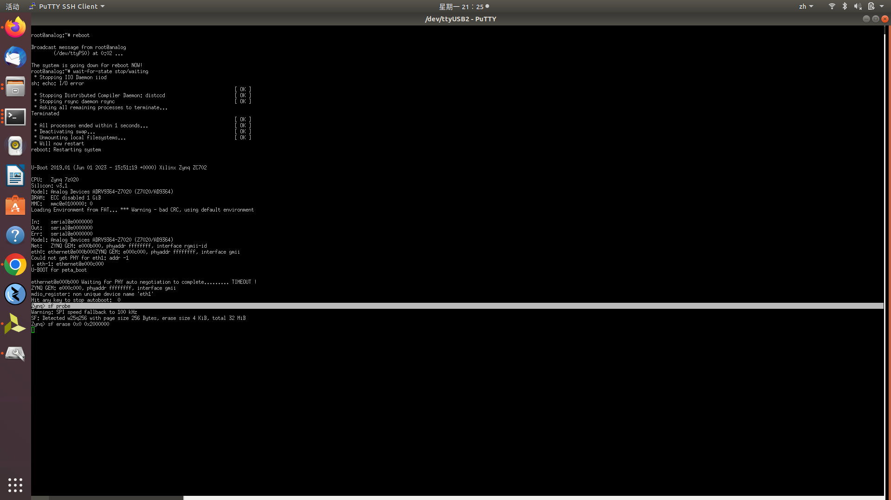
- 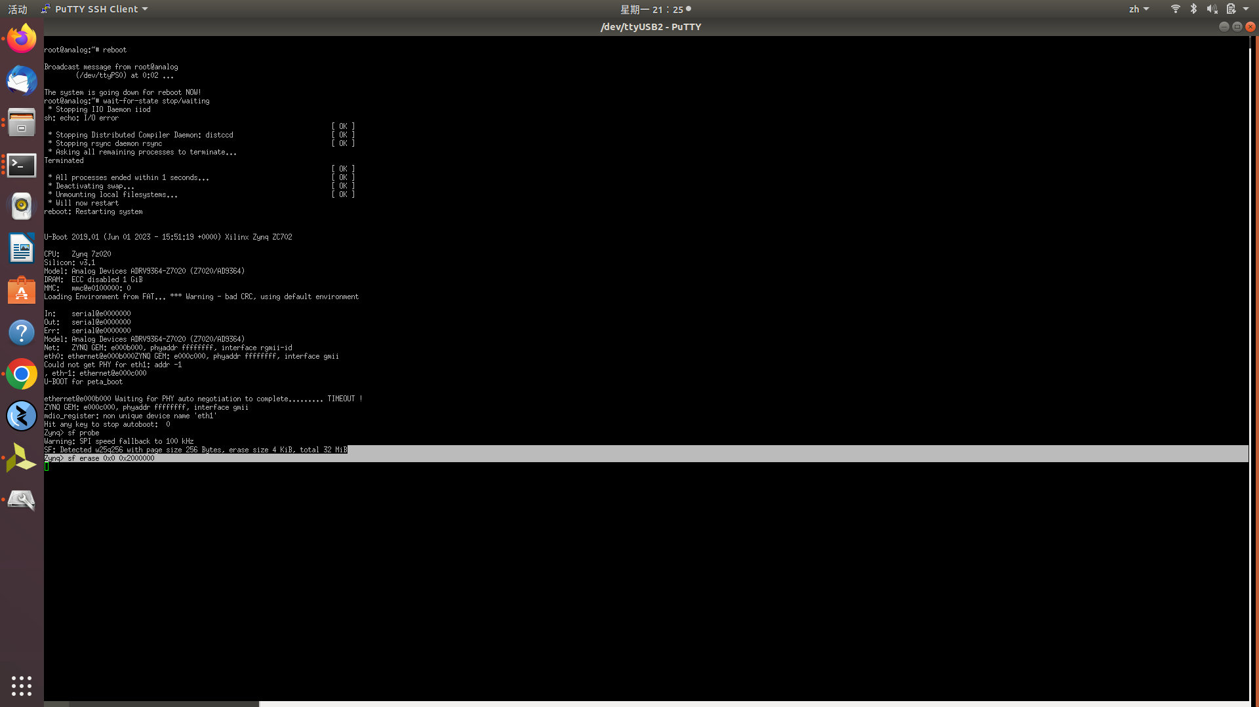
- Enter commands

- Reboot
- Type when the countdown
- Type sf probe
- Type sf erase 0x0 0x2000000
- Type boot
- mount /dev/mmcblk0p1 /mnt
- cd /mnt/burn_flash
- chmod +x autoconfig.sh
- ./autoconfig.sh

- 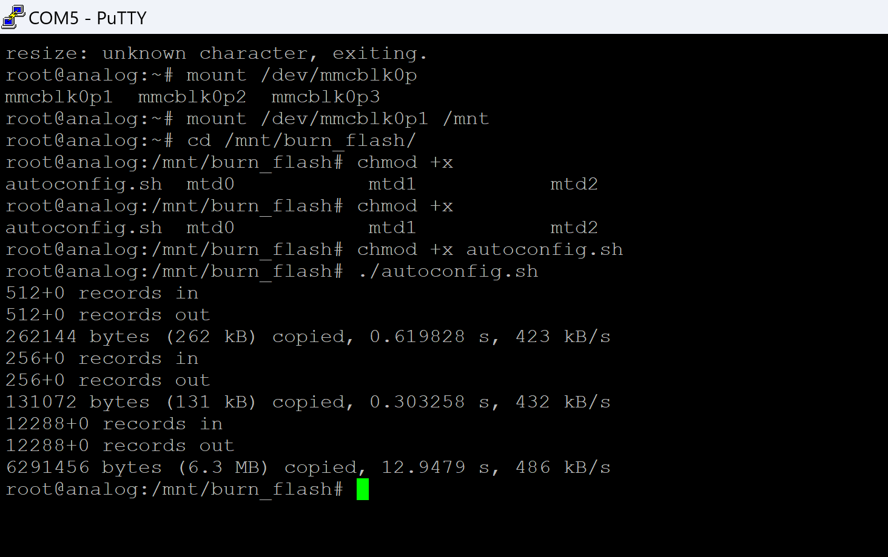
- Wait for complete;
- Enter the poweroff command
- 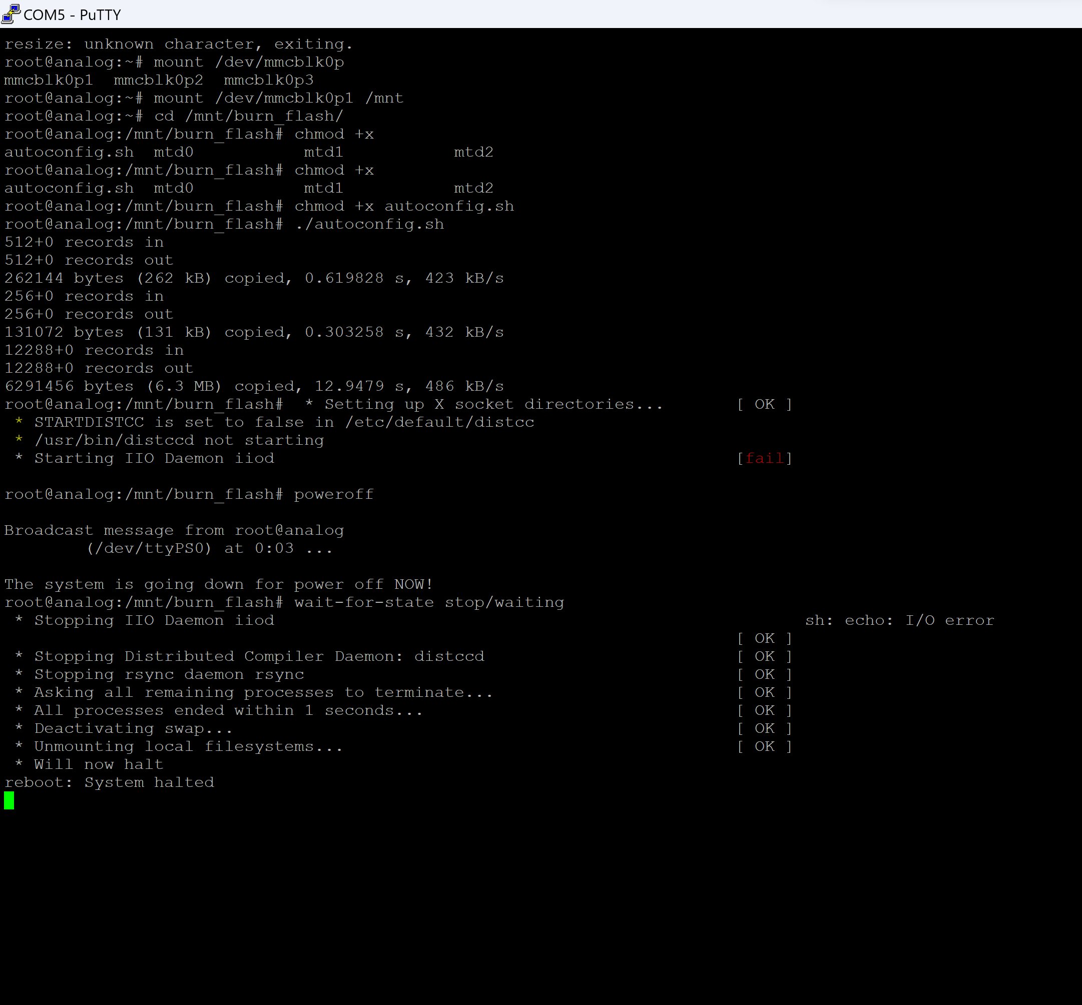

- Congratulations, you have completed 99% of the work

- Install the pluto driver Windows Drivers [Analog Devices Wiki]

- Connect the module use the otg port;

- 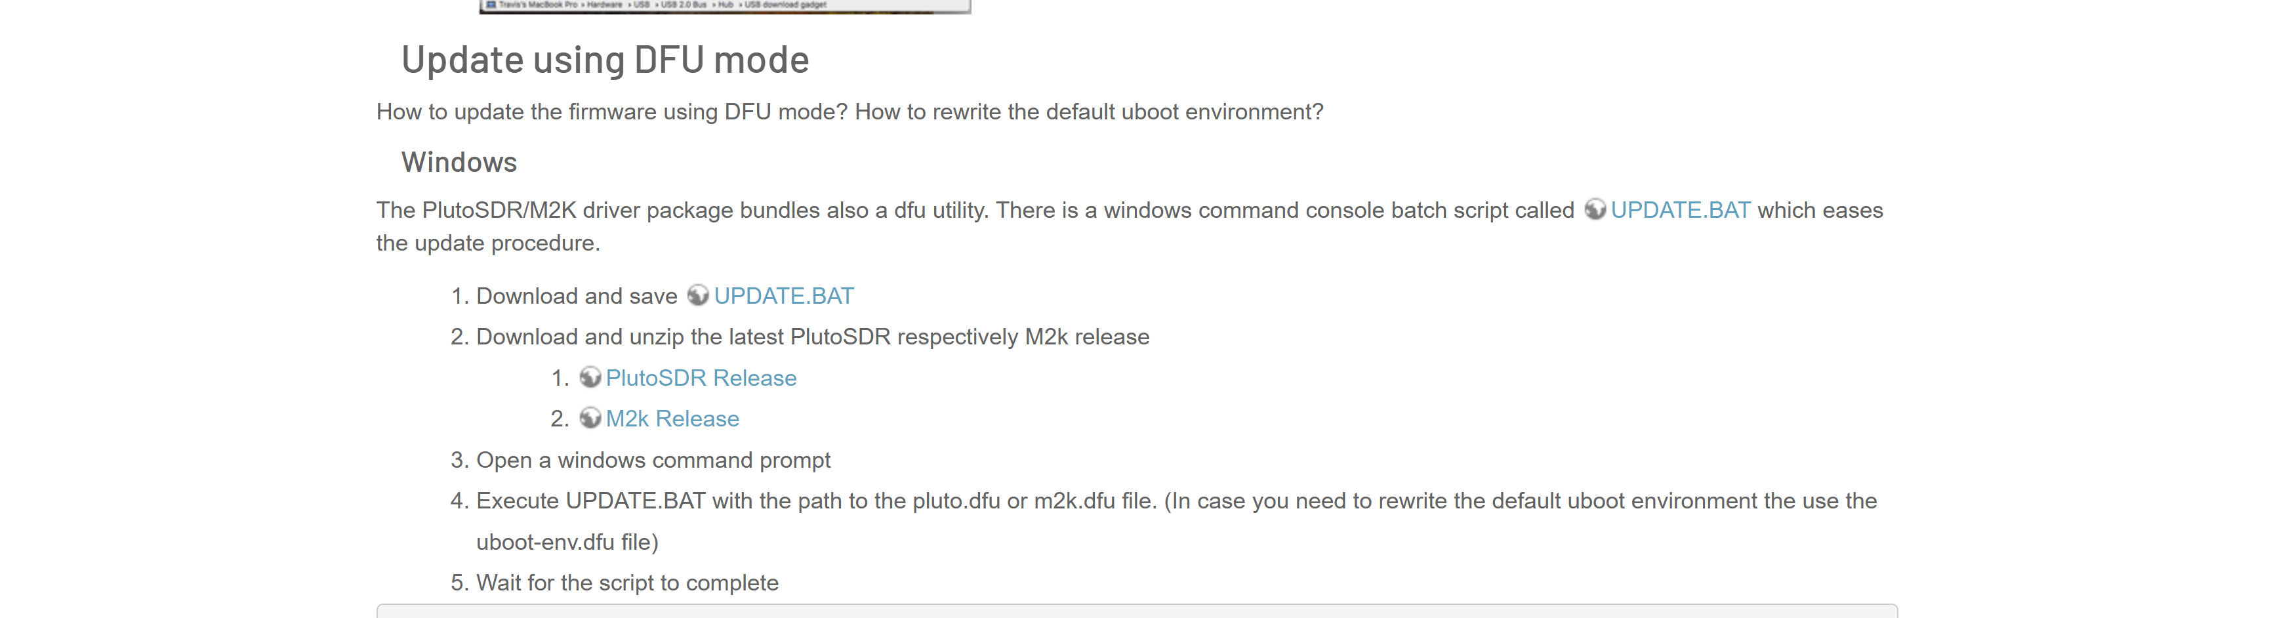

- Pluto/M2k Firmware Updates [Analog Devices Wiki] Update the firmware I provided with UPDATE.BAT

- 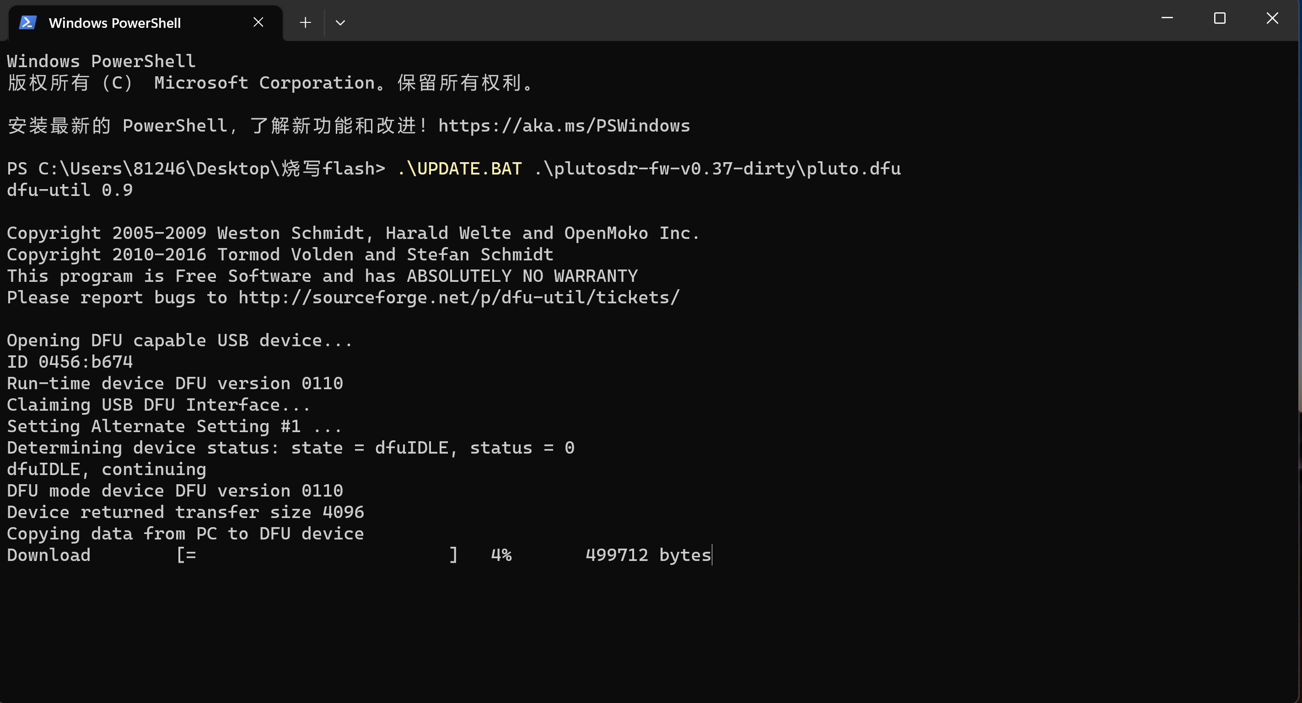

- Wait for a moment

- 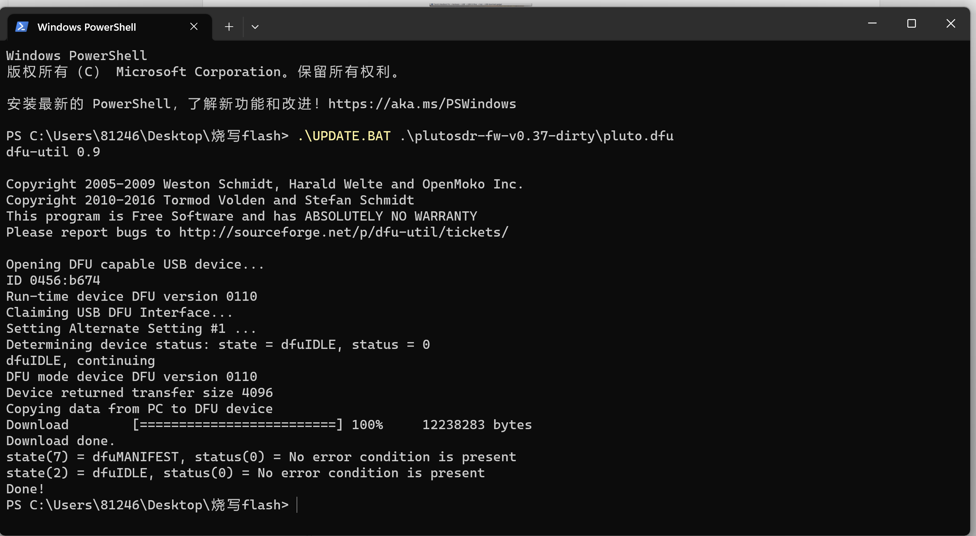

- Reconnect the usb.

- You will see an LED flashing;

Summary:
1. We use SD cards to burn down the basic parts
2. Using dfu to burn and write pluto firmware
Attention points:
When using dfu mode, unplug the SD card

